Университет ИТМО, факультет программной инженерии и компьютерной техники
Двухнедельная отчётная работа по «Информатике»: аннотация к статье

Дата прошедшей лекции | Номер прошедшей лекции | Название статьи/главы книги/видеолекции | Дата публикации (не старше 2022 года) | Размер статьи (от 400 слов) | Дата сдачи
10.09.2025 | 1 | Decimal Versus Binary Representation of Numbers in Computers | 1.10.2022 | 4424 | 24.09.2025
24.09.2025 | 2 | Data Compression Technology Explained: Balance between Costs & Performance | 8.11.2022 | 2562 | 08.10.2025
08.10.2025 | 3 | Mastering Regular Expressions with Python | 01.08.2023 | 1711 | 05.11.2025
05.11.2025 | 4 | Microservices Data Formats: JSON, XML, Protobuf, Thrift, and Avro | 08.09.2024 | 2145 | 19.11.2025
 | 5
 | 6
 | 7

Выполнил(а) Цэрэндорж Ариунбат , № группы P3113 , оценка
^{Фамилия И.О. студента} ^{не заполнять}
Прямая полная ссылка на источник или сокращённая ссылка (bit.ly, tr.im и т.п.)
https://medium.com/%40alxkm/microservices-data-formats-json-xml-protobuf-thrift-and-avro-4dc4965f33f2
Теги, ключевые слова или словосочетания (минимум три слова)
Structured data serialization, Binary communication protocols, Human-readable data formats
Перечень фактов, упомянутых в статье (минимум четыре пункта)
- JSON is a widely used, simple data format that’s easy for humans to read and works with almost every programming language.
- However, JSON doesn’t enforce a strict schema, which can lead to data inconsistencies since there’s no built-in way to require specific fields or types.
- Protobuf uses a compact binary format with clearly defined schemas, allowing microservices to exchange data quickly and efficiently while maintaining compatibility over time.
- Apache Thrift, developed by Facebook, is a cross-language serialization framework that relies on its own Interface Definition Language (IDL) and binary encoding, but it is harder to learn, and the data is not human-readable.
- Avro from Apache supports rich data types and schema evolution, but because it’s binary, it’s not human-readable and typically requires a schema registry to manage schemas.
Позитивные следствия и/или достоинства описанной в статье технологии (минимум три пункта)
- JSON’s human-readable format makes development and debugging simpler, allowing teams to spot problems quickly and share data without relying on complicated tools.
- XML’s built-in support for schemas helps enforce data structure, making it easier for systems to catch errors early and keep data consistent across different services.
- Protobuf’s binary format provides high performance, enabling faster communication and smaller message sizes between microservices, which is ideal for systems that need efficiency.
- Thrift’s ability to work across multiple programming languages allows different systems to communicate Smoothly, making it particularly useful in large, diverse architectures where interaction is important.
Негативные следствия и/или недостатки описанной в статье технологии (минимум три пункта)
- JSON can become inconsistent because it doesn’t enforce a strict schema which may lead to errors in large systems.
- XML is very verbose and heavy making it slower to process and harder to work with compared to lighter formats.
- Protobuf is not human-readable so debugging requires special tools and is more difficult than with text formats.
- Thrift has a steep learnirng curve since it uses its own IDL and binary format, which complicates development and troubleshooting.
Ваши замечания, пожелания преподавателю или анекдот о программистах
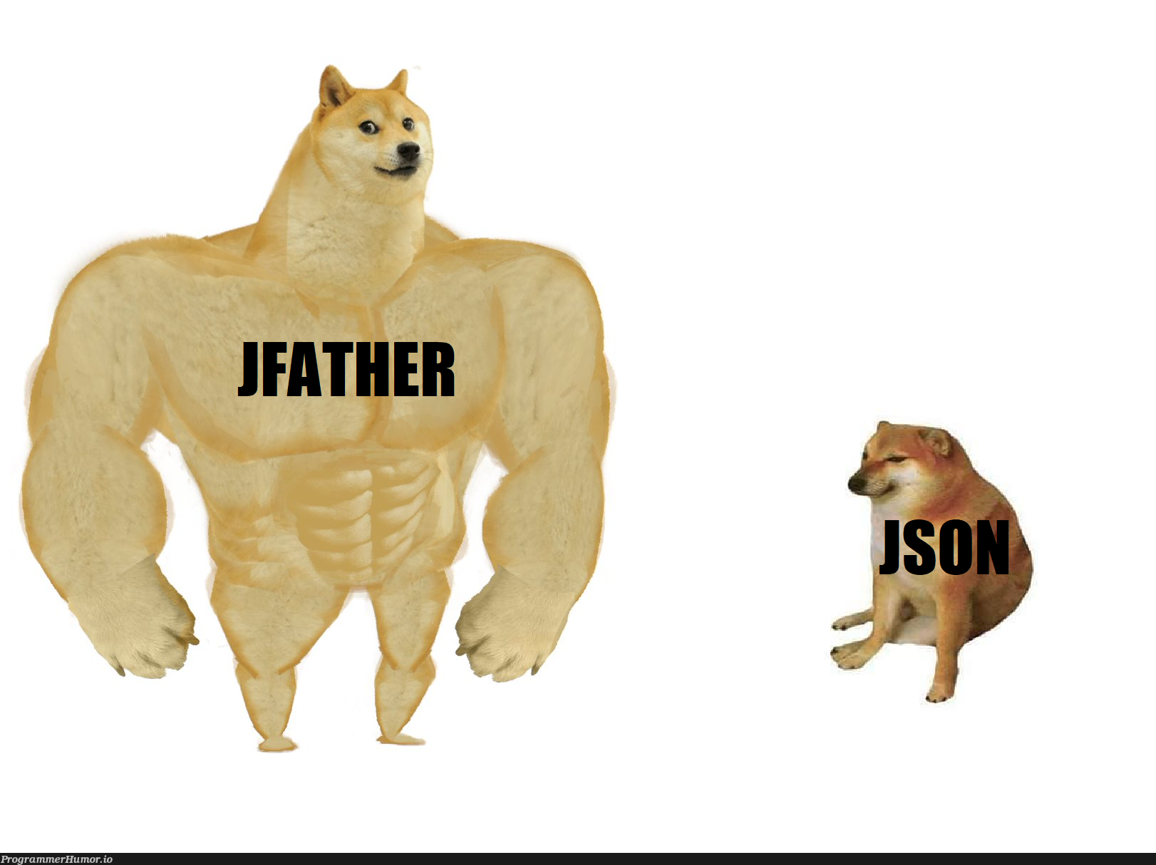

Наличие этой графы не влияет на оценку

